Save Food, Spend Less Challenge promotional materials

About the challenge
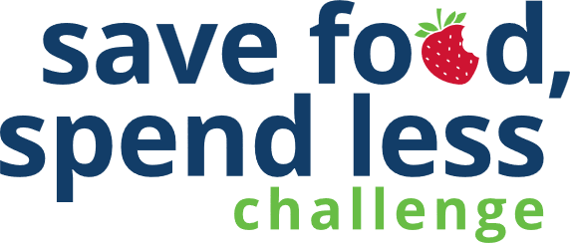
We toss nearly 40% of food in the U.S., much of it coming from our homes. For a family of four, that can add up to more than $3,000 in wasted food every year. It’s not just a waste of money. Wasting food also wastes the water, fertilizer, land, and labor needed to get that food from the fields to your table
By coming together with our community, we can make a real difference for our paychecks and the planet.
The Save Food, Spend Less Challenge, savefoodmn.ecochallenge.org, is a four-week challenge held from October 1-31 that will help participants learn why food goes to waste in their households and improve skills in cooking, planning, shopping, and storing food. The challenge has more than 60 actions to choose from. Participants check off the actions they already take, then select up to 10 actions to track progress on during the challenge.
Participants create or join a team to take the challenge along with their family, friends, or neighbors. Organizations and businesses can become a Save Food, Spend Less Challenge partner and help increase promotion, recruitment, and engagement for the challenge.

Contact
The online Save Food, Spend Less Challenge is offered in partnership with Hennepin, Ramsey, and Washington counties on the EcoChallenge platform.
Contact the Zero Waste Challenge coordinator at ZWC@hennepin.us

Updated July 2026


6 ways to promote the challenge
Help spread the word about the Save Food, Spend Less Challenge:
- Become a Save Food, Spend Less Challenge partner. (page 3)
- Post or hand out flyers (page 3) to encourage others to join your team.
- Create a team or join an existing team and invite people you know – friends, family, neighbors, colleagues, etc. Invitations can be sent through the Save Food, Spend Less Challenge website.
- Share the sample articles (pages 4-6) on your organization’s website or in emails or newsletters.
- Use sample social media posts and graphics (pages 7-12) to share on your social media channels. Tailor the message for your audience.
- Follow and reshare messages posted on the Hennepin, Ramsey, and Washington counties’ social media channels:
  - Hennepin County:
    - Hennepin Environment on Facebook
    - @hennepinenvironment on Instagram
    - @HennepinEnviro on X
  - Ramsey County:
    - Ramsey County Minnesota on Facebook
    - @ramseycountymn on Instagram
    - @RamseyCounty on X
  - Washington County:
    - Washington County MN on Facebook
    - @WashingtonCoMN on Twitter
Download additional resources from savefood.ecochallenge.org/about/resources

Become a partner
By coming together with our community, we can make a real difference for our paychecks and the planet. But we can’t do it alone!
Learn how to become a 2026 partner and fill out the partnership form. Businesses, community groups, cities, neighborhoods, schools, and retailers are welcome partners.

What does it mean to be a partner?
There are many ways to be a partner in the challenge. Here are some ways we ask partners to get involved. Find the way that works for you!
- Expand our reach by promoting the challenge to your audience.
- Strengthen engagement in the challenge by creating teams of colleagues, friends, and neighbors who provide motivation, accountability, and friendly competition.
- Increase our impact by offering educational events or promotions on food waste prevention topics.
Partners help promote the challenge, and we help promote you! All partners will have their logo displayed on the challenge website, gain access to promotional materials, and get recognition and cross-promotion during the challenge. There is no cost to become a partner.

Posters and flyers
Download posters and flyers to help promote the challenge and encourage others to join your team:
- Join the challenge flyer
  - Full page 8.5x11 (PDF)
  - Half page 5.5x8.5 (PDF)
- Join our team flyer 8.5x11 (PDF)
- Join the challenge event poster 11x17 (PDF)
- Composting connection drop-off poster 11x17 (PDF)

Newsletter articles
Save money focus

Join the Save Food, Spend Less Challenge
What would you do with an extra few thousand dollars? The average family of four spends $3,000 a year on food they end up throwing away. The Save Food, Spend Less Challenge will help improve your skills in cooking, planning, shopping, and storage to save time, money, and resources.
Find what works in your household during the four-week challenge – from easier meal planning to better food storage. Team up with your community to make a real difference in reducing waste.
Sign up starting September 1. The challenge will take place October 1 to 31, kicking off during national Food Waste Prevention Week.

Save resources focus

The planet will thank you: Join the Save Food, Spend Less Challenge
Despite our best efforts, we all toss out perfectly good food. About 40% of food in the U.S. is wasted, much of it coming from our homes, wasting the money we spent on it and the resources used to grow, ship, and store it.
The Save Food, Spend Less Challenge is your chance to turn small, everyday habits into big wins for your paycheck and the planet. Less wasted food means fewer emissions, cleaner air, and a lighter footprint on the environment.
Ready to make a difference—one meal at a time? Join the online challenge and discover smart tricks for planning meals, making the most of what you buy, and contributing to real change in your home and community.
The challenge will take place October 1-31, kicking off during national Food Waste Prevention Week. Sign up by September 30.

Graphic for save money or save resources focused articles
Download graphics at savefoodmn.ecochallenge.org/about/resources
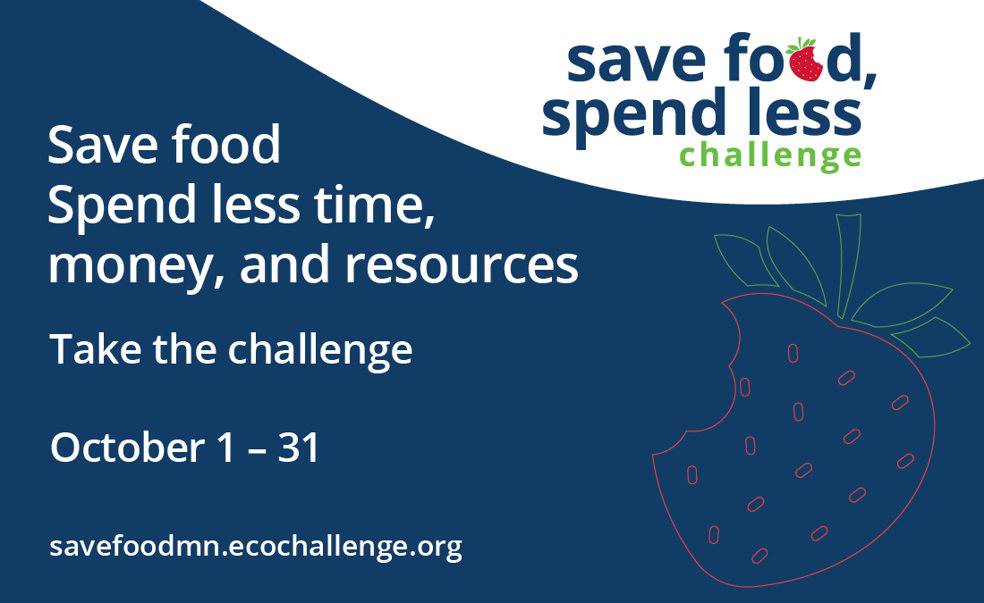

Composting connection
Note: Update the name of the composting/organics recycling program to what is used in your community. Most Hennepin County communities use organics recycling pickup or drop-off, while Ramsey County and Washington County communities use food scraps recycling pickup or drop-off.

Take your composting to the next level: Join the Save Food, Spend Less Challenge
Thank you for keeping food out of the trash through the organics recycling program! Take the next step by using up your food instead of composting it.
While organics recycling makes a positive impact on reducing waste, tossing food we could have eaten wastes the money we spent on it and the resources that went into making it.
Take the Save Food, Spend Less Challenge this October to improve your skills in cooking, planning, shopping, and storage. Less wasted edible food, more time, money, and resources saved!

Graphic for composting connection article
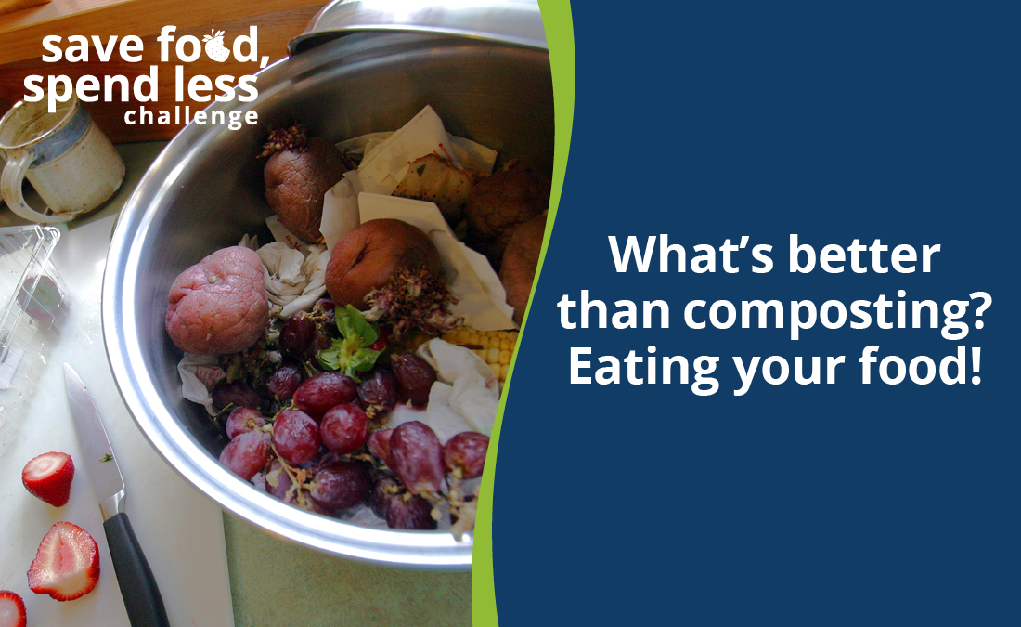

Social media posts
Suggested hashtags: #SaveFoodSpendLess #StopFoodWaste #SaveFood #ZeroWaste
To use images and graphics: right click on the image and select Save as Picture.
Download all graphics at savefoodmn.ecochallenge.org/about/resources

Post 1: Join the challenge

Facebook
Join the Save Food, Spend Less Challenge this October. Learn how to save up to $3,000 a year on groceries, spend less time on meal planning and shopping, and gain control in your kitchen. Come together with your community to collaborate and compete for the benefit of our paychecks and the planet. Sign up by September 30. savefoodmn.ecochallenge.org

Instagram
Join the Save Food, Spend Less Challenge this October. Learn how to save up to $3,000 a year on groceries, spend less time on meal planning and shopping, and gain control in your kitchen. Come together with your community to collaborate and compete for the benefit of our paychecks and the planet. Sign up by September 30 at the link in our bio.
#SaveFoodSpendLess #StopFoodWaste #SaveFood #ZeroWaste

X/Twitter
Join the Save Food, Spend Less Challenge this October. Learn how to save up to $3,000 a year on groceries, spend less time on meal planning and shopping, and gain control in your kitchen. Sign up by September 30. savefoodmn.ecochallenge.org

NextDoor
Join the Save Food, Spend Less Challenge this October. Learn how to save up to $3,000 a year on groceries, spend less time on meal planning and shopping, and gain control in your kitchen. Come together with your community to collaborate and compete for the benefit of our paychecks and the planet. Sign up by September 30. savefoodmn.ecochallenge.org

Graphics
Use the square graphic for Instagram and Facebook posts, the vertical for Instagram stories, and the horizontal for X/Twitter and Nextdoor posts,. For Instagram stories, you can also add a link to savefoodmn.ecochallenge.org/about/resources.
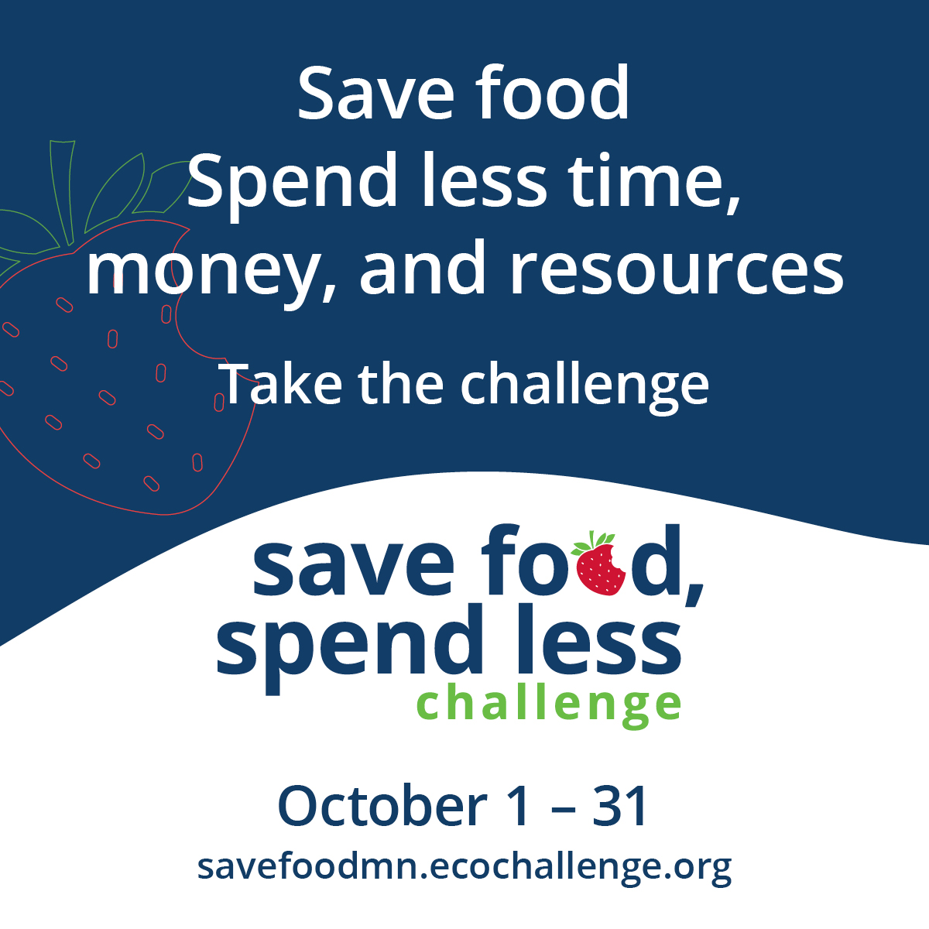
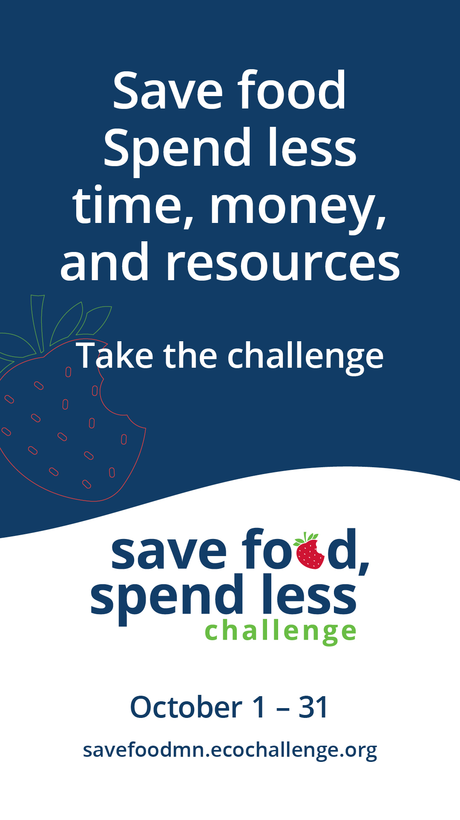

Post 2: Save money

Facebook
What would you do with an extra few thousand dollars? The average family of four spends $3,000 a year on food they end up throwing away. This October, take the Save Food, Spend Less Challenge to help you improve skills in cooking, planning, shopping, and storage to save time, money, and resources. Sign up by September 30. savefoodmn.ecochallenge.org

Instagram
What would you do with an extra few thousand dollars? The average family of four spends $3,000 a year on food they end up throwing away. This October, take the Save Food, Spend Less Challenge to help you improve skills in cooking, planning, shopping, and storage to save time, money, and resources. Sign up by September 30 at the link in our bio.
#SaveFoodSpendLess #StopFoodWaste #SaveFood #ZeroWaste

X/Twitter
What would you do with an extra few thousand dollars? The average family of four spends $3,000 a year on food they end up throwing away. This October, take the Save Food, Spend Less Challenge to learn habits that save time, money, and resources. Sign up by September 30. savefoodmn.ecochallenge.org

Graphics
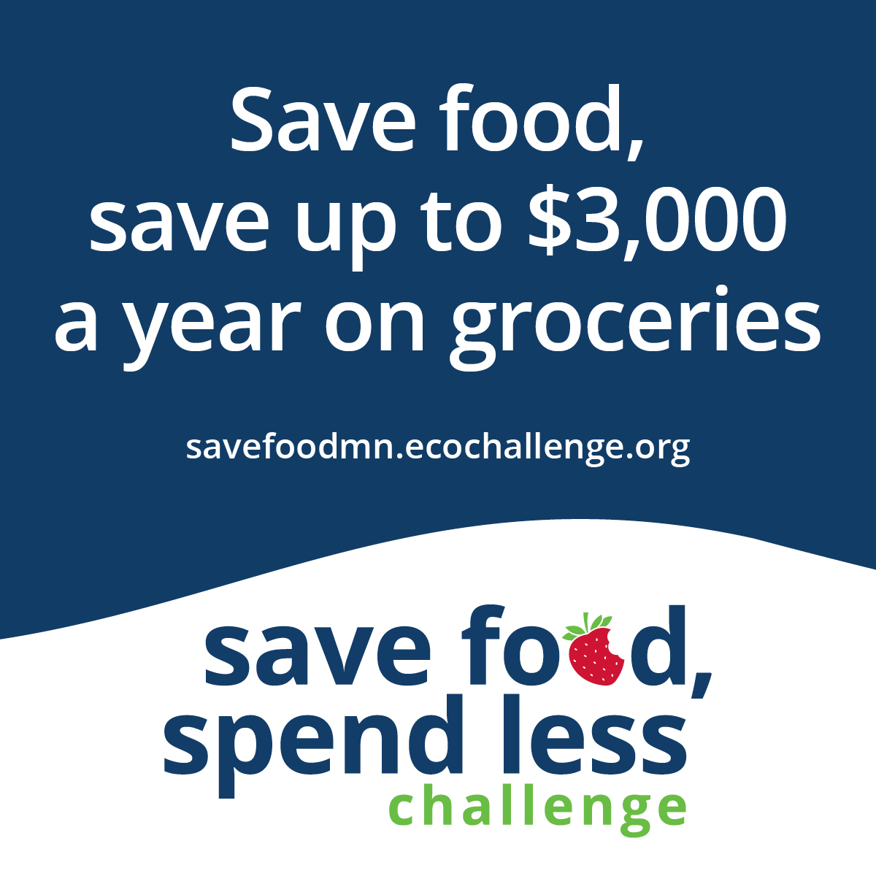

Post 3: Big wins for your paycheck and the planet

Facebook
Despite our best efforts, we all toss out perfectly good food. About 40% of food is wasted in the U.S., much of it coming from our homes, wasting the money we spent on it and the resources used to grow, ship, and store it. The Save Food, Spend Less challenge is your chance to turn small, everyday habits into big wins for your paycheck and the planet. Join now. savefoodmn.ecochallenge.org

Instagram
Despite our best efforts, we all toss out perfectly good food. About 40% of food is wasted in the U.S., much of it coming from our homes, wasting the money we spent on it and the resources used to grow, ship, and store it. The Save Food, Spend Less challenge is your chance to turn small, everyday habits into big wins for your paycheck and the planet. Join now at the link in our bio.
#SaveFoodSpendLess #StopFoodWaste #SaveFood #ZeroWaste

X/Twitter
Despite our best efforts, we all toss out perfectly good food, wasting money and resources. Turn everyday habits into big wins for your paycheck and the planet with the Save Food, Spend Less challenge savefoodmn.ecochallenge.org

Graphics
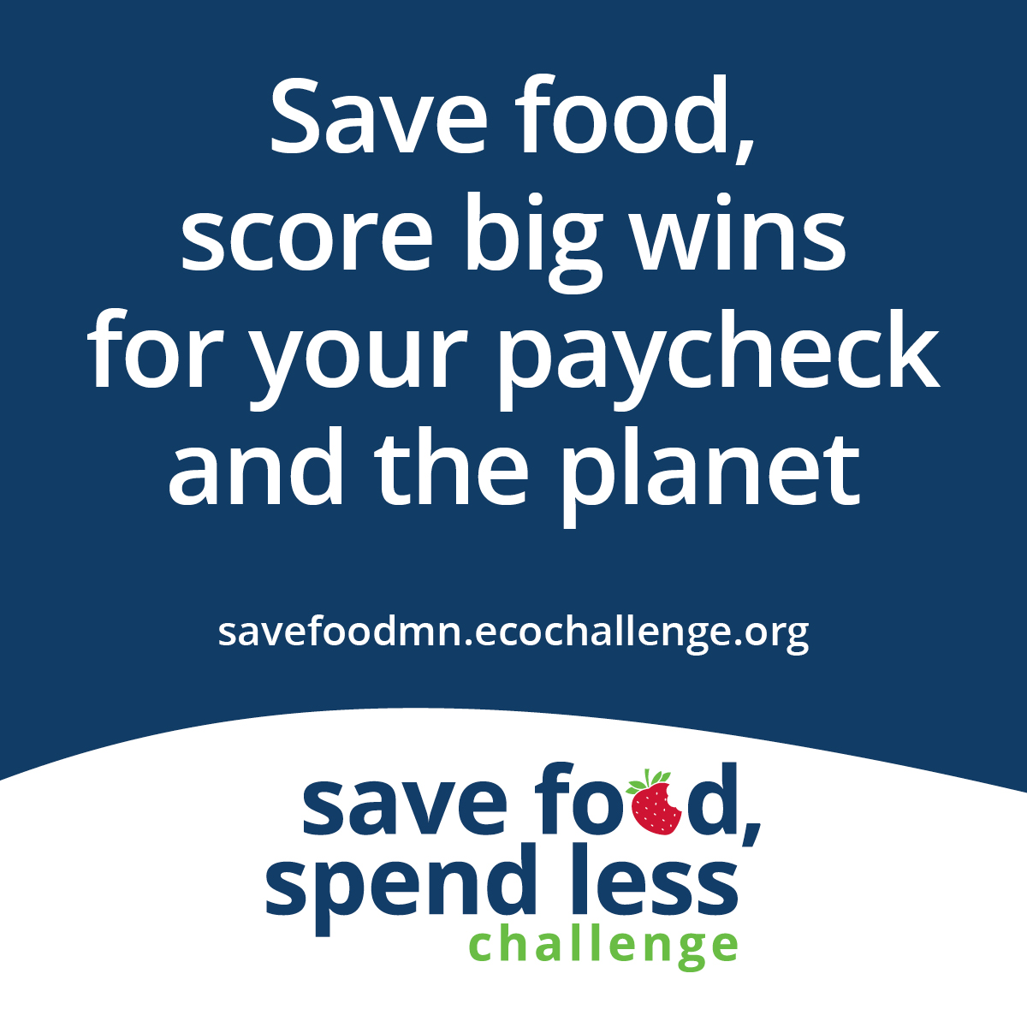

Post 4: Team up

Facebook
It’s time to team up for the Save Food, Spend Less Challenge! Learn to use up your food to save time, money, and resources. Come together with our community to collaborate and compete for the benefit of our paychecks and then planet. Sign up at savefoodmn.ecochallenge.org and join our team (optionally, insert the name of your team)

Instagram
It’s time to team up for the Save Food, Spend Less Challenge! Learn to use up your food to save time, money, and resources. Come together with our community to collaborate and compete for the benefit of our paychecks and then planet. Sign up at the link in our bio and and join our team (optionally, insert the name of your team)

X/Twitter
It’s time to team up for the Save Food, Spend Less Challenge! Come together to collaborate and compete for the benefit of our paychecks and then planet. Sign up at the link in our bio and join our team (optionally, insert the name of your team)

NextDoor
It’s time to team up for the Save Food, Spend Less Challenge! Learn to use up your food to save time, money, and resources. Come together with our community to collaborate and compete for the benefit of our paychecks and then planet. Sign up at savefoodmn.ecochallenge.org and join our team (optionally, insert the name of your team)

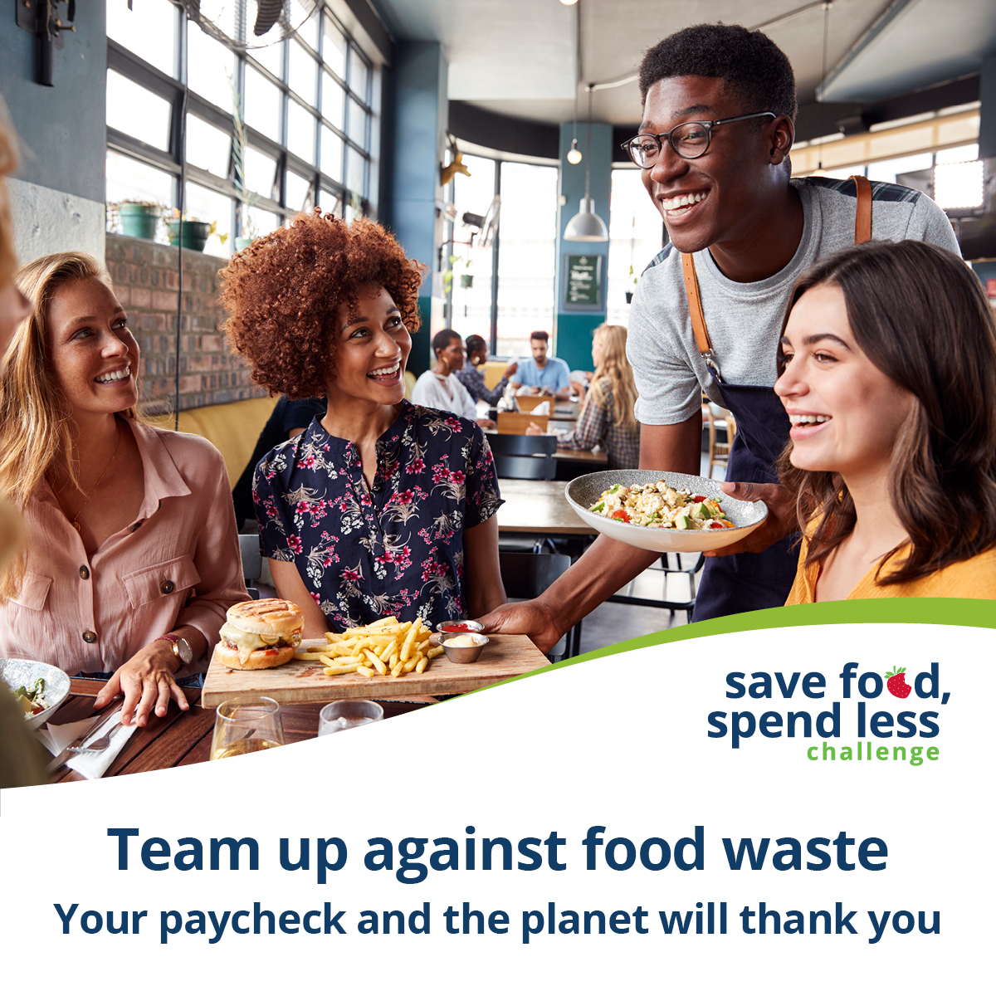
Graphics

Post 4: Organics recycling connection

Facebook
What’s better than composting? Eating your food!
While organics recycling makes a positive impact on reducing waste, tossing food we could have eaten wastes the money we spent on it and the resources that went into making it.
Join the Save Food, Spend Less Challenge to improve your skills in cooking, planning, shopping, and storage. Less wasted edible food, more time, money, and resources saved! Sign up by September 30 at savefoodmn.ecochallenge.org

Instagram
What’s better than composting? Eating your food!
While organics recycling makes a positive impact on reducing waste, tossing food we could have eaten wastes the money we spent on it and the resources that went into making it.
Join the Save Food, Spend Less Challenge to improve your skills in cooking, planning, shopping, and storage. Less wasted edible food, more time, money, and resources saved! Sign up by September 30 at the link in our bio.
#SaveFoodSpendLess #StopFoodWaste #SaveFood #ZeroWaste

X/Twitter
What’s better than composting? Eating your food! Join the Save Food, Spend Less Challenge to improve skills in cooking, planning, shopping, and storage. Less wasted edible food, more time, money, and resources saved! savefoodmn.ecochallenge.org

Graphics
